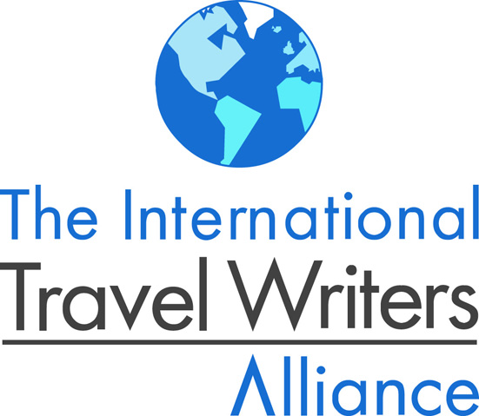

Destination cultural Orlando

Produced by the International Travel Writers Alliance with the support of the Orlando Peabody Association for

Arts and Culture

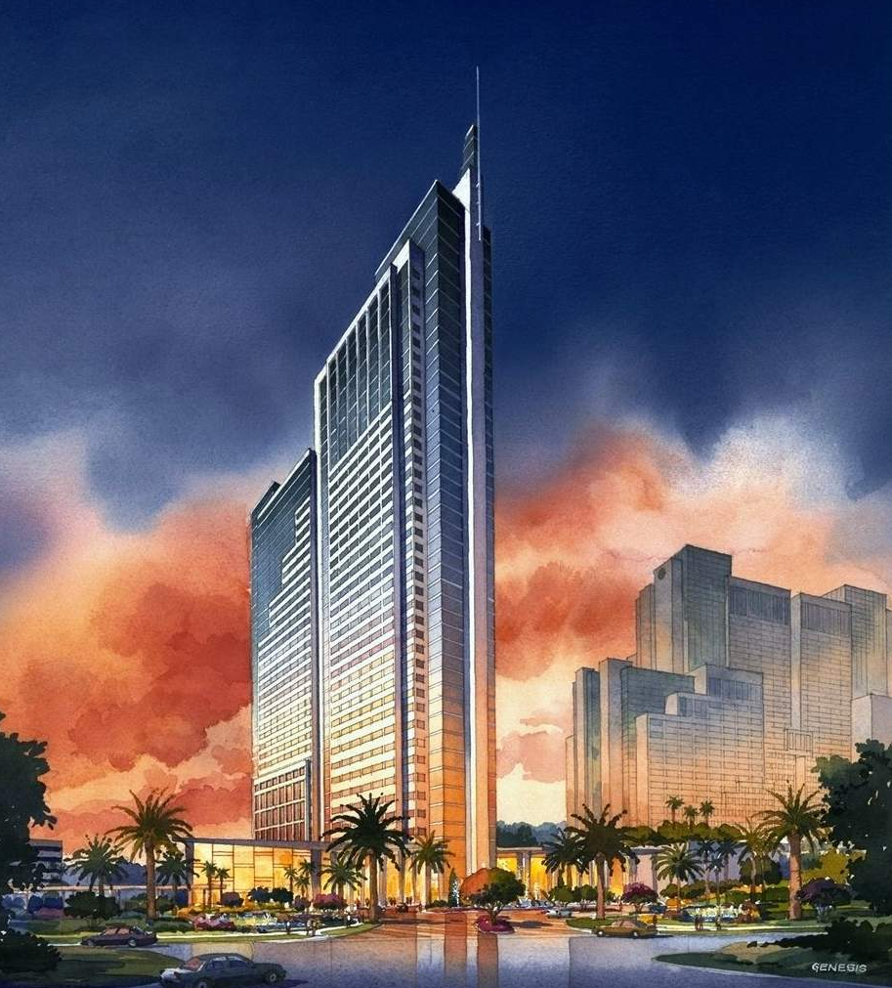

Sponsored by the Peabody Hotel, Orlando

June 2008

Destination Cultural Orlando

Destination Cultural Orlando has been produced by the International Travel Writers Alliance with the support of the Orlando/Peabody Alliance for the Arts & Culture (OPAAC).

It provides a media resource for professionals looking to visit Orlando, Florida to write, broadcast or create images that will highlight the cultural opportunities in the city and surrounding area.

OPAAC will be delighted to talk to Alliance members about sourcing other story and feature ideas.

The contents

- OPAAC
- Working with the Alliance
- A personal perspective
- Reasons to write about Cultural Orlando
- A place to stay in Orlando
- Sources
- Getting to Orlando
- Other information
- The International Travel Writers Alliance

The Orlando Peabody Association for Arts and Culture

Since 1996, members of Central Florida's arts and culture community have been promoting cultural tourism in the Orlando through the Orlando Peabody Association of Arts and Culture (OPAAC).

The public/private partnership is spearheaded by The Peabody Orlando, a luxury, 891-room convention/resort hotel. Participating organisations include :

- Cornell Fine Arts Museum
- Enzian Theatre
- Orlando Museum of Art
- Orlando Philharmonic
- Charles Hosmer Museum of American Art
- The Maitland Art Center
- Festival of Orchestras
- Association to Preserve the Eatonville Community, Inc.
- Crealde School of Art
- Orlando Opera Company
- Orlando Science Center
- Orlando Shakespeare Festival
- Orlando Ballet
- Holocaust Memorial Resource/Museum
- Albin Polacek Garden/Gallery/Museum
- Scenic Boat Ride, and
- Central Florida Ballet.

OPAAC membership is open to organisations who :

- the organization must be based in central Florida
- are professional, non-profit organisations engaged in the visual or performing arts, and/or
- create and/or hosts cultural events in the area.

Working with the Alliance

The following key contacts will be pleased to work with Alliance members on assignment, with a commission or who are able to obtain one and who would be interested in visiting Orlando to feature its arts and cultural activities.

Key contacts:

OPAAC

Maureen Gonzalez
Director of Corporate Communication for Peabody Hotels
Maureen.Gonzalez@peabodyorlando.com
(407)-345-4521

Visit : http://www.peabodyorlando.com/

Orlando tourism

Donna Taliercio
International Media Manager
Orlando/Orange County Convention & Visitors Bureau
Donna.Taliercio@orlandocvb.com
(407)-363-5883

Visit : www.orlandoinfo.com/media.

A personal perspective

By Ashley Gibbins

Like millions of Brits my first long haul was to ‘Disney’, the generic shorthand for the seven big theme parks, the themed night-time entertainment districts and the dozens of smaller themed attractions that festoon the undisputed ‘theme capital’ of the world.

As a weathered travel hack, I may now recount tales of more adventurous destinations.

But give me a couple of margarita’s (on the rocks with salt) and I wallow happily in the warm remembered glow of my first stroll along the Magic Kingdom’s Main Street, USA.

The problem is, of course, that the alternatives don’t get a look in.

So when the ‘seen it done it bought the T-shirt’ for the theme parks kicks in we tend to ignore Orlando as a destination.

A big mistake because Orlando has a great deal to offer sans-Disney.

Daily scheduled flights from destinations worldwide, quality accommodation, excellent dining opportunities, good shopping and a great exchange rate on the dollar all makes Orlando accessible and economically very attractive.

Then there’s Florida’s glorious weather (outside the sweltering summer period).

What more could one want? Well what about a little culture?

Professional ballet and opera companies and a philharmonic orchestra all thrive in Orlando, the Shakespeare Festival interprets the Bard to a standard that Stratford would be proud of and the Mad Cow runs a highly regarded, ten production, fringe theatre season each year.

Add to this and any number of fascinating museums and stunning art galleries and one begins to get Orlando in perspective.

Finally the delightfully serene haven of Winter Park, less than six miles from downtown Orlando, is rightly able to proclaim itself the city of arts and culture.

Credit for raising Orlando’s profile as cultural tourist offering must go to the Orlando Peabody Alliance for Arts and Culture (OPAAC).

OPAAC galvanises the marketing efforts of over 32 member organisations and this passionate cultural community is beginning to get its voice heard and to attract a steadily increasing flow of visitors to Orlando who want more than the ‘mouse’.

Reasons to write about Cultural Orlando

The performing arts

The Bob Carr Centre

The 2,500-seater Bob Carr centre must be one of Orlando’s best kept secrets.
In recent years it has staged everything from ballet and opera to Broadway productions, ranging from Lloyd Webber’s “Phantom of the Opera” to Rigoletto, to a Mahler evening and ballets based on Camelot and Cinderella. It is also the home of the Orlando Philharmonic and Central Florida Ballet.
The centre forms part of the Orlando Centroplex - off intersection 83 of Interstate 4 - where the programme includes sporting events such as ice hockey and basketball, as well as major exhibitions.

Ballet

Orlando Ballet (is a professional ballet company in every sense of the word with 28 international dancers performing four major productions between September and May.

Visit : www.orlandoballet.org.

Central Florida Ballet stages the Annual World Ballet Competition and several professional productions annually including "Nutcracker" and also has a thriving Ballet School, all under the direction of Romanian ballet star, Vasile Petrutiu.
Visit : http://www.centralfloridaballet.com.

Opera

Orlando Opera Company has achieved national and international recognition. As many productions are performed in Italian, French or German, Orlando Opera always provides sub-titles or English translations of what is being sung

Visit : www.orlandoopera.org.

Classical music

The Orlando Philharmonic Orchestra has 80 professional musicians performing well over 100 concerts and musical performances between October and May.

The Festival of Orchestras, features the world's most celebrated symphony orchestras and conductors.

Visit : www.orlandophil.org

Theatre

The Orlando Shakespeare Festival performs professional productions of Shakespeare, classics and contemporary plays in three indoor theatres including the Lowndes Shakespeare Center in Loch Haven Cultural Park and outdoors at the 950 seat Lake Eola Amphitheater in downtown Orlando.

Visit : www.orlandoshakes.org

Fringe theatre

In the last eight years the Mad Cow Theatre (www.madcowtheatre.com) has established itself as one of Orlando's most respected professional theatre companies by performing a wide range of classic and contemporary plays during each ten production season. You might also want to check out the Orlando Repretory Company (www.orlandorep.com).

The visual arts

American

Founded in 1924, the Orlando Museum of Art is an educational institution and leading cultural institution in the region, whose mission reflects the community support for the arts. The Museum has dedicated itself to collecting, preserving and interpreting notable works of art; to presenting exhibitions of local, regional, national and international significance; to developing first-rate educational programs; and to presenting creative and inclusive programs to reach every segment of a diverse community.

It has an extensive collection of American art, from the 19th century to the present, African art and art of the ancient Americas. Annually, the Museum presents 10-12 exhibitions on-site and 13 exhibitions off-site.

Visit : www.omart.org.

Czech/American

The Polasek Museum and Sculpture Gardens showcases the work of Albin Polasek, one of America's most prominent twentieth century sculptors, in his Winter Park home and lakeside gardens.

Visit : www.polasek.org.

Tiffany

The Charles Hosmer Morse Museum of American Art (houses the world's most comprehensive collection of the works of Louis Comfort Tiffany including jewellery, pottery, paintings, art glass, leaded-glass windows, lamps, and the chapel interior he designed for the 1893 World's Columbian Exposition in Chicago.

Visit : www.morsemuseum.org.

Other cultural attractions in Orlando

- The City Hall of Orlando - Terrace Gallery showcases Florida artists and travelling exhibits.

- The Orange County Regional History Center and Heritage Square (http://www.thehistorycenter.org) Set in the 1927 Orange County Courthouse, this award-winning museum explains Florida's diverse history from Native Americans to cartoon heroes.

- Orlando Science Center (www.osc.org) has dozens of interactive exhibits plus an eight-story CineDome screen, the world's largest domed theatre and planetarium.

- Enzian Cinema (www.enzian.org) is Florida's only not-for-profit cinema and the best place to see non-mainstream movies.

- The Menello of American Art Museum http://www.mennellomuseum.org/) is a quirky museum showcasing unique paintings and works of folk artists from Central Florida and throughout the U.S. The Mennello features noted area artist Earl Cunningham whose vivid paintings, with their highly saturated colors, seem to pop off the gallery walls.

- The City of Orlando’s public art programme (www.cityoforlando.net/arts/public_art/whatispublicart.htm) places works of art in highly trafficked areas for public viewing. Large-scale sculptures, exhibition spaces, and site-integrated aesthetic works are all examples of public art. Concentrating on downtown plazas, city parks, neighbourhood community centres, and municipal buildings, the Public Art Program strives to place artwork in highly visible locations and choose artwork that reflects the character of that community.

A place to stay

The Peabody Hotel

The Peabody Orlando enjoys contemporary design and luxurious décor and furnishings. It is one of only two Mobil Four-Star, AAA Four Diamond hotels in Orlando.

The Peabody will be delighted to consider offering accommodation to Alliance members on assignment, with a commission or who are able to obtain one.

Visit : http://www.peabodyorlando.com/. Contact : Maureen Gonzalez on (407)-345-4521 or at
Maureen.Gonzalez@peabodyorlando.com.

Orlando has a huge range of accommodation from budget to upmarket. Visit : www.orlandoinfo.com/accommodations/.

Guide books to Orlando

Insight (www.insightguides.com) and Lonely Planet (www.lonelyplanet.com) both produce excellent guides to Orlando and Florida. These two and the following publishers will be happy to provide review copies to Alliance members on assignment, with commission or who are able to secure one and in return for a credit or review

Berlitz : Visit : www.berlitzpublishing.com. Contact : Julia Spence at julia.spence@ukonline.co.uk

Bradt Travel : Visit: www.bradtguides.com Contact: Debbie Hunter at debbie.hunter@bradtguides.com

Brit's Guide : Visit : www.foulsham.com. Contact Margaret Lashbrook at margaret.lashbrook@lineone.net or Sue Wilkins at wilkins@foulsham.com.

Eland Publishing : Visit: www.travelbooks.co.uk. Contact: Barnaby Rogerson at barnaby@travelbooks.co.uk.

Global Travel Publishers : Visit : www.africa-adventure.com. Contact Kate Bandos at kate@ksbpromotions.com.

Insight : Visit : www.insightguides.com. Contact : Julia Spence at Julia.spence@ukonline.co.uk.

Lonely Planet : Visit: www.lonelyplanet.com. Contact: Europe, Middle East and Africa: Louise McDonald Louise.MacDonald@lonelyplanet.co.uk, North and Central America: Rand Freedman at rana.freedman@lonelyplanet.com.au; Australia, New Zealand and Asia: Simone McNamara at simone.mcnamara@lonelyplanet.com.au.

Rough Guides : Visit : www.roughguides.com. Contact : press@roughguides.

Getting to Orlando

By air

Orlando International Airport (www.orlandoairports.net) is the major public commercial service airport located six miles (10 km) southeast of Orlando. It is the busiest airport in Florida owing to Orlando's popularity as both a tourist and business destination and served by airlines worldwide. Visit :

The Greater Orlando area is also served by Orlando Sanford International Airport (www.orlandosanfordairport.com) .

By road

Interstate 4 or the I-4 corridor is a 132.30-mile connects the Tampa, Lakeland, Orlando and Daytona Beach metropolitan areas.

Car hire

All major car rental companies operate in Florida.

Dollar (www.dollar.com) provide an extensive network and excellent service and will offer media rates to Alliance members on assignment, with a commission or who are able to obtain one. Contact : Jayne Gaffney at UKInfo@DTAG.Com.

The International Travel Writers Alliance

The International Travel Writers Alliance provides key information and support for 7,000 professionals who travel to write, edit, broadcast or create images.

Alliance information is also syndicated to 500 professional travel writers through the North American Travel Journalists Association, 1200 travel writers through the Society of American Travel Writers, 600 travel writers through the Professional Writers Association of Canada and directly to 150 members of the New Zealand Travel Communicators.

Visit: www.internationaltravelwritersalliance.com. Contact : Ashley Gibbins on +44 (0) 776 419 8286 or Ashley@ITWAlliance.com.

